KAPLAN SINGAPORE

COMPULSORY ASSESSMENT

FEEDBACK SHEET

|  |  |  |  |
| --- | --- | --- | --- |
| **NAME:** | **FILL IN HERE** | **PRID:** | **FILL IN HERE** |

|  |  |  |  |
| --- | --- | --- | --- |
| **Module Code:** | **CE303** | **Title:** | **Advanced Programming** |

**In addition to the feedback below, please consult the generic feedback on Moodle.**

**Comments:**

**Key areas for improvement:**

|  |  |  |  |
| --- | --- | --- | --- |
| **Mark:** |  | **Grade:** |  |
| Marker: |  | Date: |  |

|  |  |  |  |
| --- | --- | --- | --- |
|   **Assignment Coversheet**   * **Please complete and attach this form to your assignment. All assignments must be submitted on the stipulated submission date.**   **Program / Intake : PT UOE BScCS 4**  **Pathway: Bachelor of Science (Honours) in Computer Science**  **Assignment Type** *(optional)***: Coursework** | | | |
| **Student Name:** | **FILL IN HERE** | **Student Number (PRID):** | **FILL IN HERE** |
| **Module Code:** | **CE303** | **Module Title:** | **Advanced Programming** |
| **Lecturer/Tutor:** | **Mr Kang Leng** | **Grade:** |  |
| **DECLARATION: I hereby declare that the attached assignment is my own work. I understand that if I am suspected of plagiarism or another form of cheating, I will be subject to disciplinary actions.**  **Signed: Date Submitted: FILL IN HERE** | | | |

Start your coursework writing in this page onwards:



**What is Anything & Anywhere?**

Anything & Anything is an innovative E-commerce platform designed to assist physical retailers in implementing online shopping into their business model. Featuring an extensive range of products from premier shopping destinations such as Parkway Parade and Katong I12. Explore diverse categories including food and beverages, clothing and apparel, groceries, and more!

**What is the goal?**

* Anything & Anything revolutionizes the shopping experience by allowing users to search for products in a single online location effortlessly.
* It attracts business owners by providing an additional stream of traffic, creating a comprehensive one-stop shop that eliminates the need to search elsewhere.
* The platform also offers expanded opportunities for logistics partners, consolidates delivery fees for purchases from multiple stores into one charge, provides exclusive offers and discounts for app users, and enables seamless in-store payment with immediate pickup. E.g. Shopee, different store different delivery charges.

**How does it benefit businesses?**

* **24/7 Availability,** allowing customers to shop at any time, any time zones.
* **Customer Insights**, gather data on customer behaviour preferences, that allow creation of marketing strategies and informed business decisions.
* **Increase Sales Channels**, utilize online platforms to open a new income stream.
* **Scalability,**  no infrastructure investments are needed.
* **Automated Operations,** automated inventory management, order processing and customer service

### **What are the challenges E-commerce is facing?**

* **Non-Adoption by Certain Businesses:** Despite the widespread adoption of e-commerce, some businesses, especially lesser-known shops tucked away in shopping malls, have yet to incorporate it into their business model.
* **Physical Service Providers:** Services such as haircuts, nail salons, and tuition centres may not be viable for e-commerce since they require clients to be physically present for service delivery.
* **Logistics: Slow delivery time, take China as a example**

**Features**

* **Extensive Product Catalogue:** Wide range of products across various categories and shopping malls!
* **Advanced Search and Filtering:** Easily find specific items with robust search and filtering options.
* **AI Chatbot Assistance:** Virtual Personal Shopping Assistants to help shoppers with their queries.
* Efficient booking of time slots for service providers
* **Real-Time Inventory Updates:** Stay informed about product availability.
* **Multiple Payment Options:** Convenient payment methods like PayNow and Shopee-Pay.

**What are the Risk?**

* **Data Security**: Protecting against data theft and breaches.

Planned to use a hashed Password instead of the plaintext password.

* **Logistics**: Ensuring efficient and reliable delivery services. Planned to outsource to freelance logistics partner.
* **Site Maintenance**: Ongoing upkeep by both business owners and the platform team.
* **Coordination with Business Owners**: Managing relationships and communication. Value their feedback.
* **Technical Challenges**: Handling issues like downtime and traffic spikes.

**What are the Technologies Involve?**

**Project Preparations**

**What are the Technologies Involve?**

|  |  |  |
| --- | --- | --- |
| Frontend | Backend (Server) | Database |
| **HTML** | **Node.js** | **MongoDB** |
| **CSS** | **Express.js** |  |
| **JavaScript** |  |  |
| **Bootstrap (Researching)** |  |  |

**Database Designing**

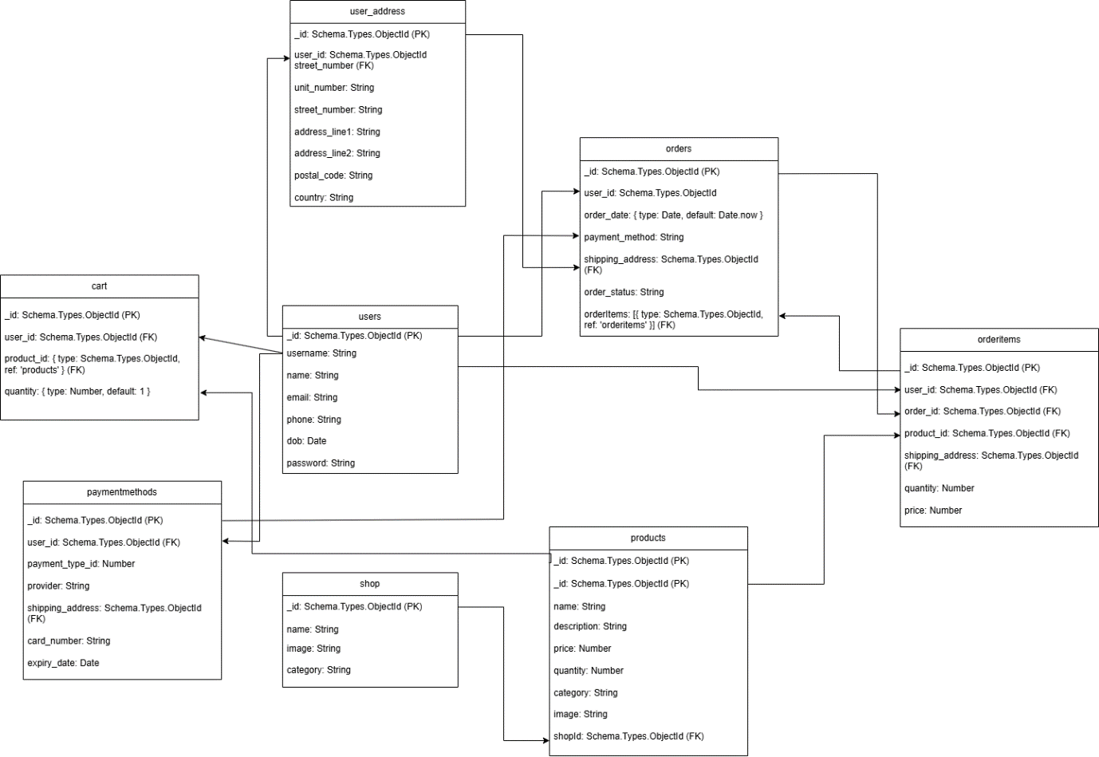

**UI Drafting**

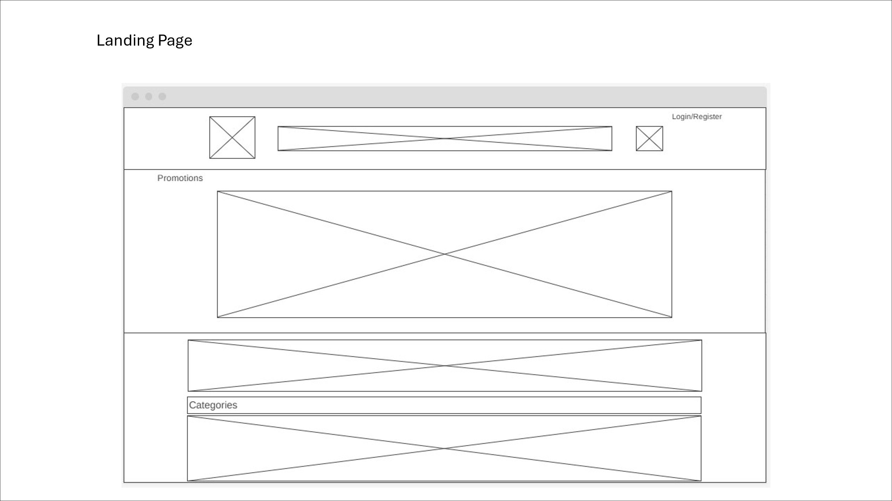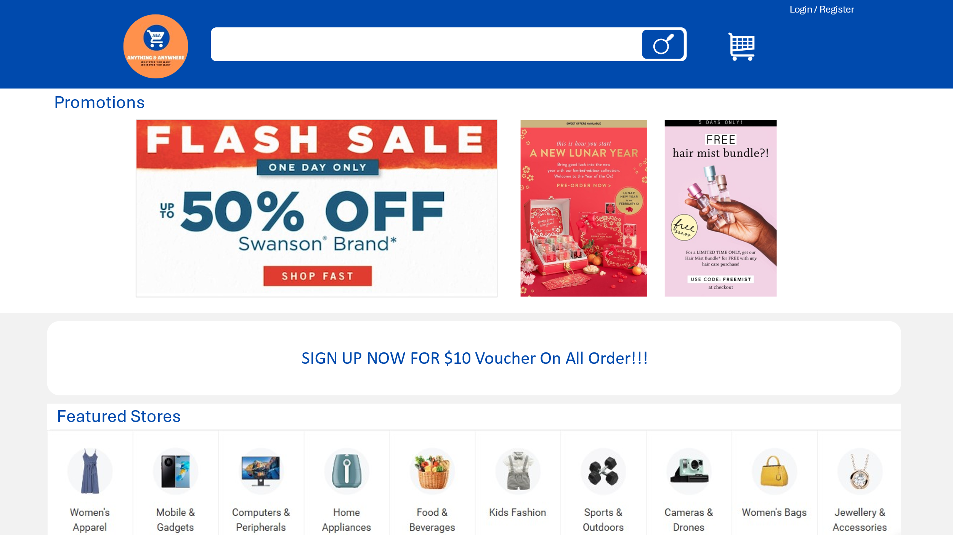

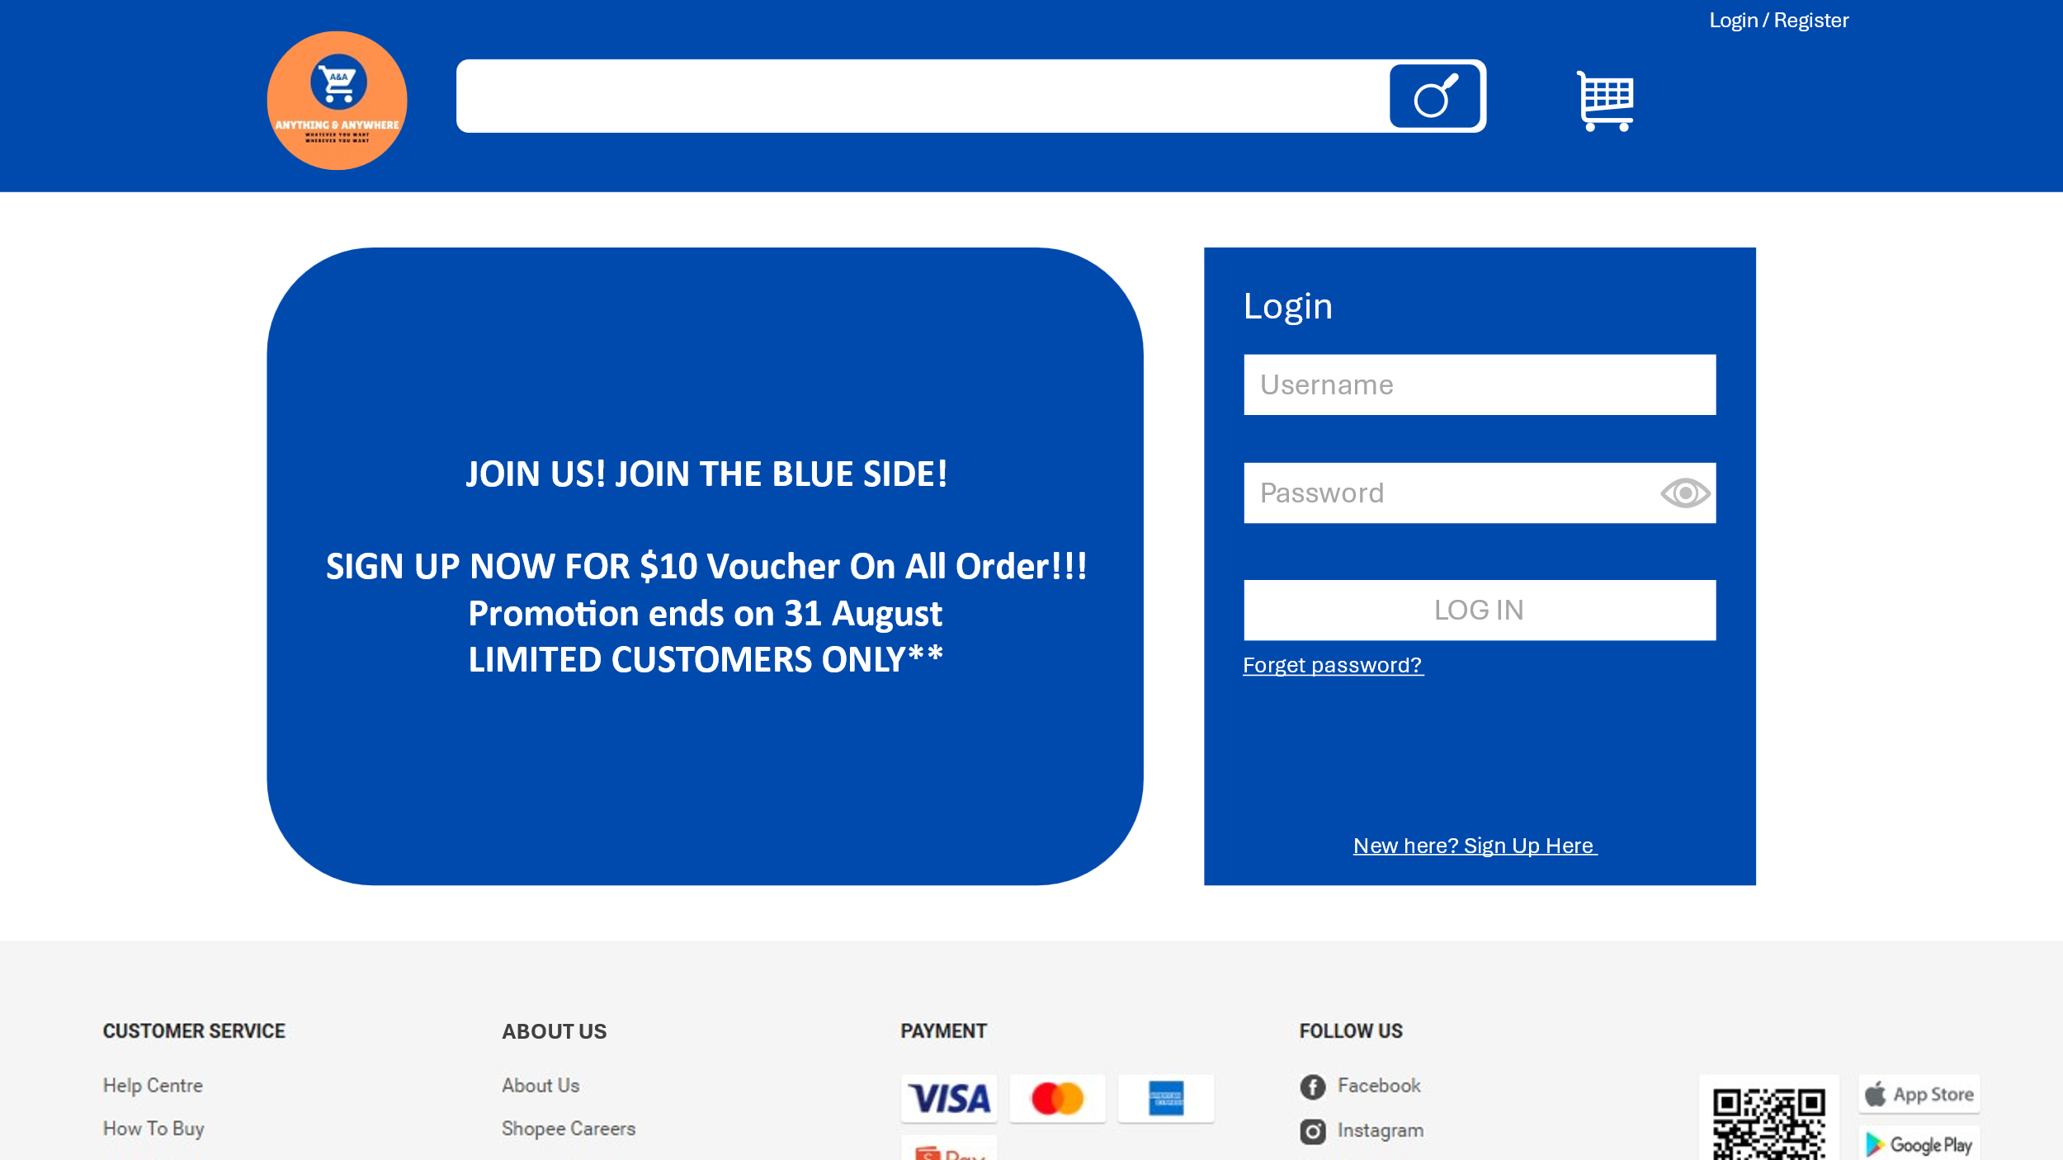



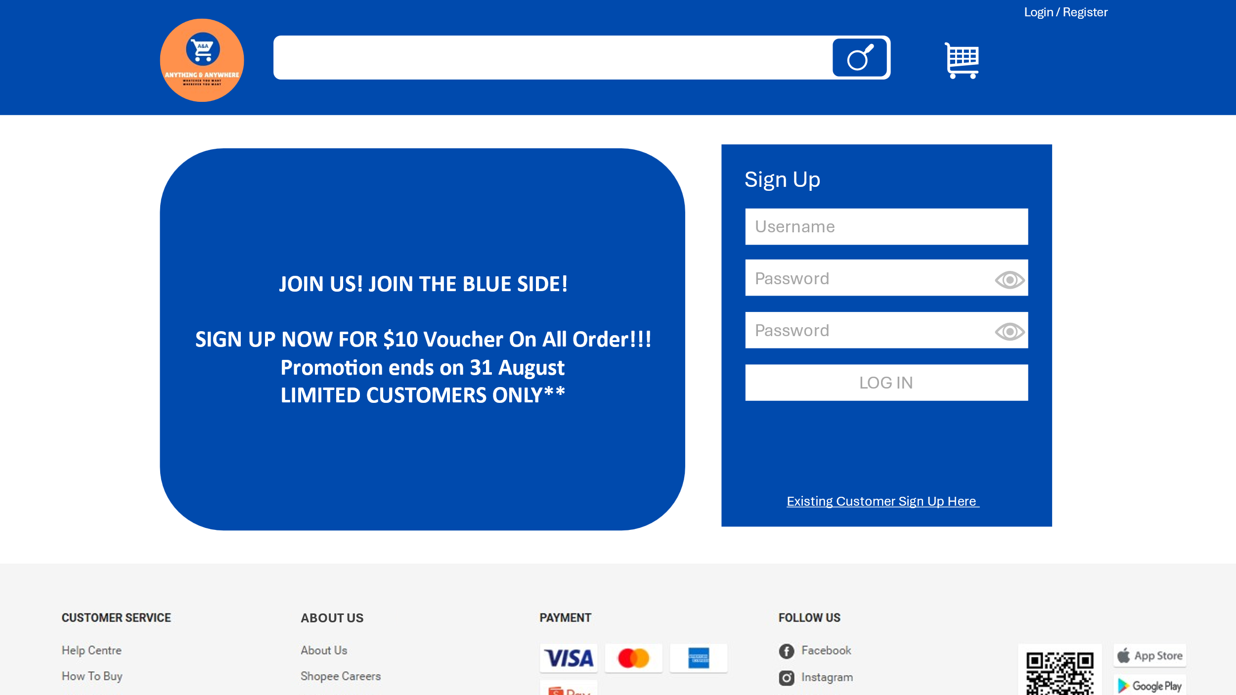

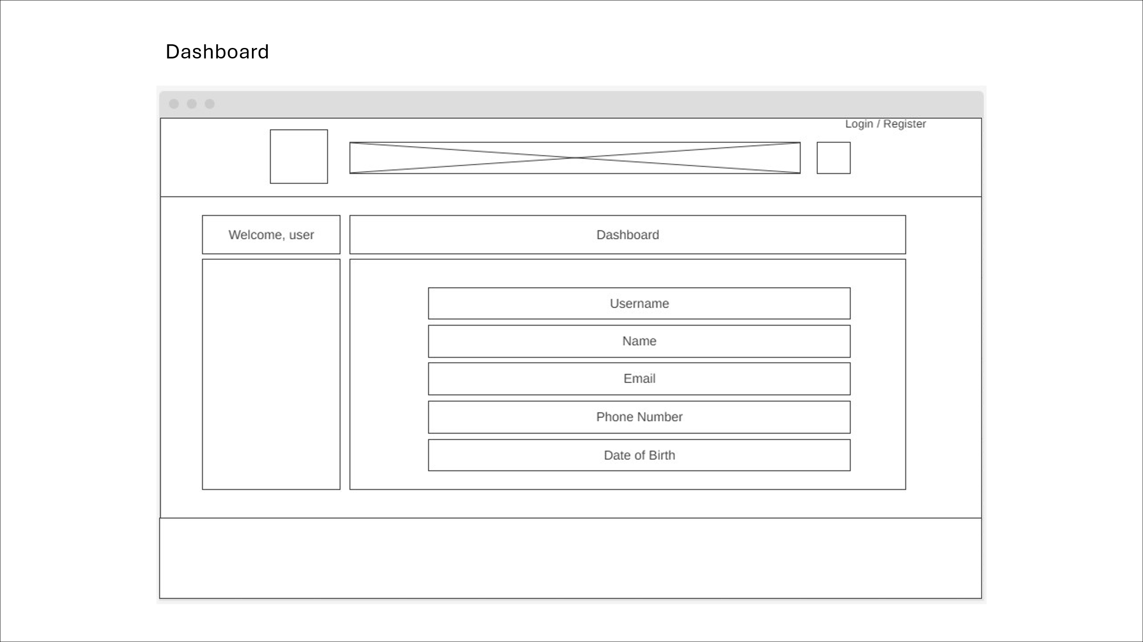

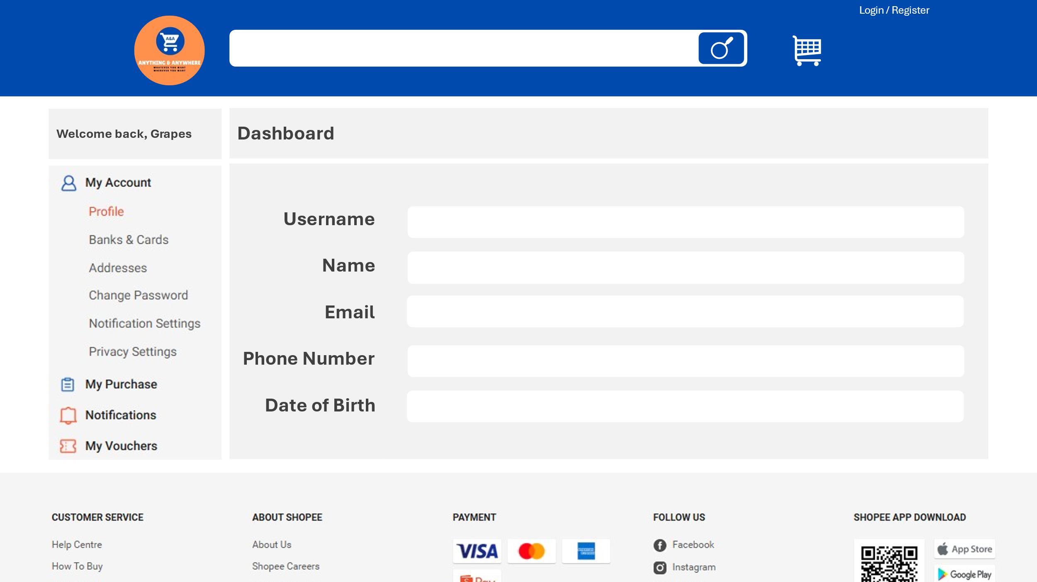



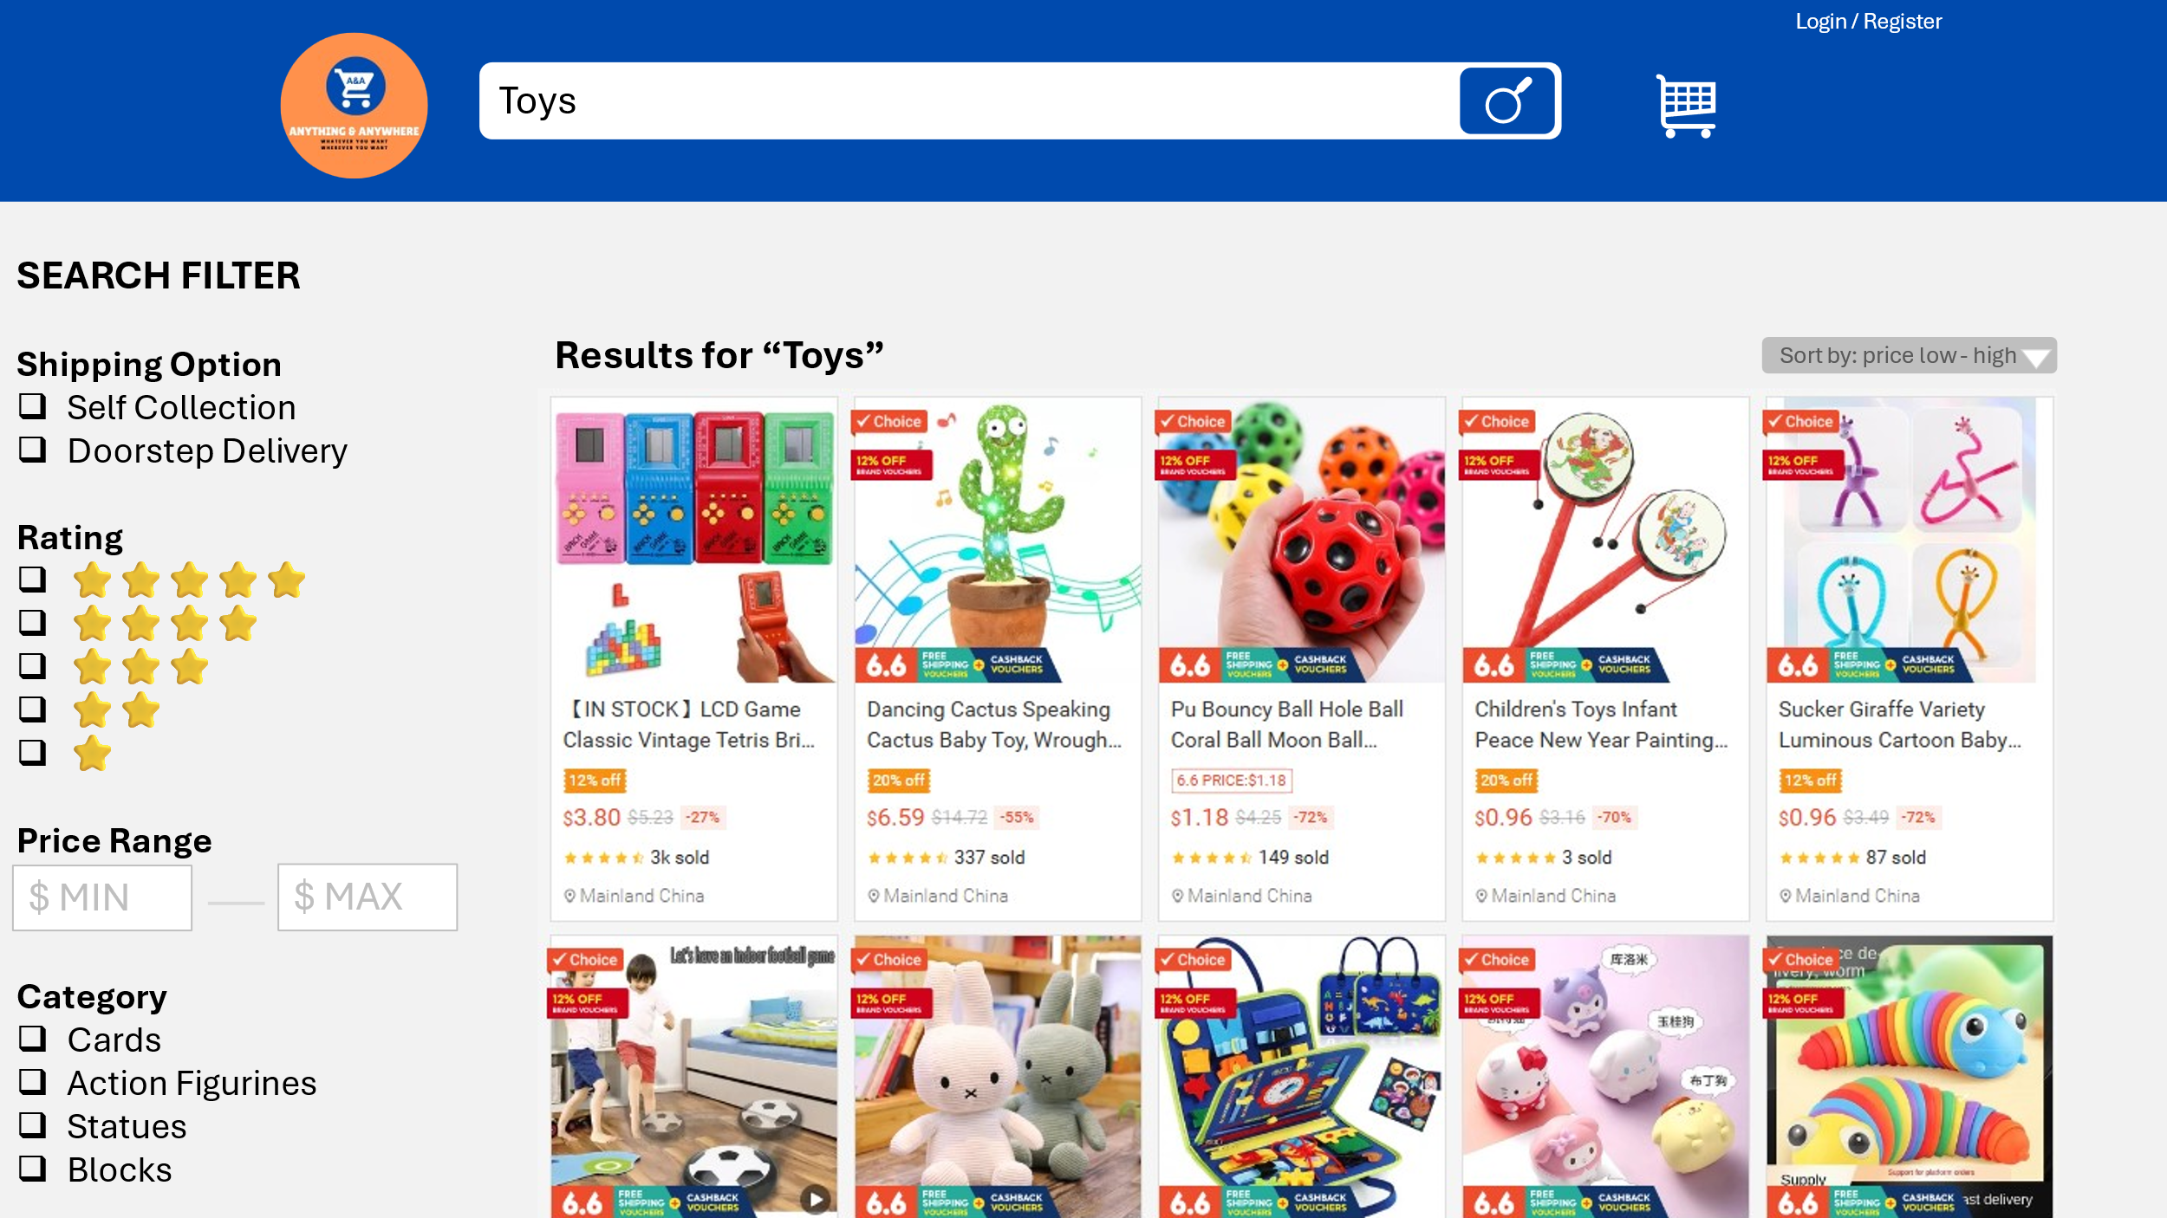

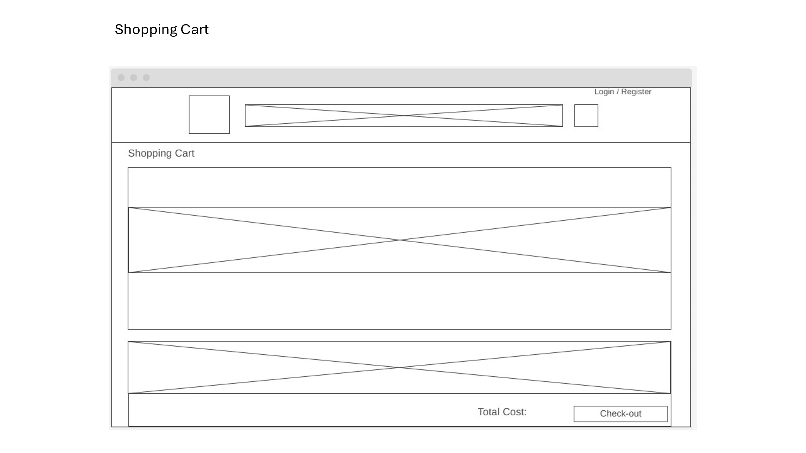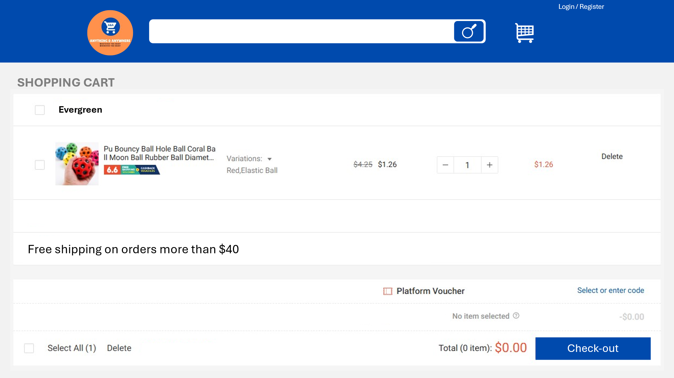

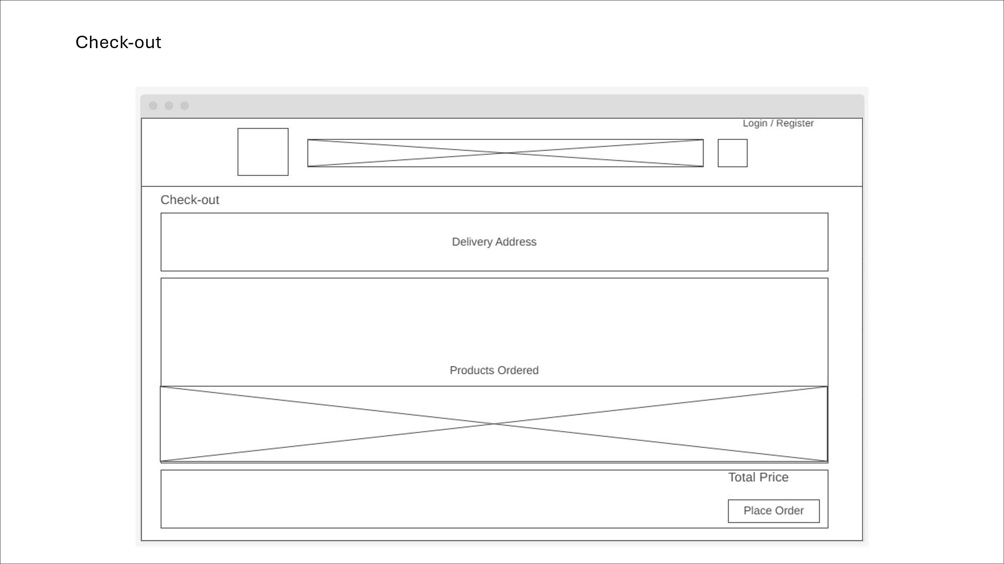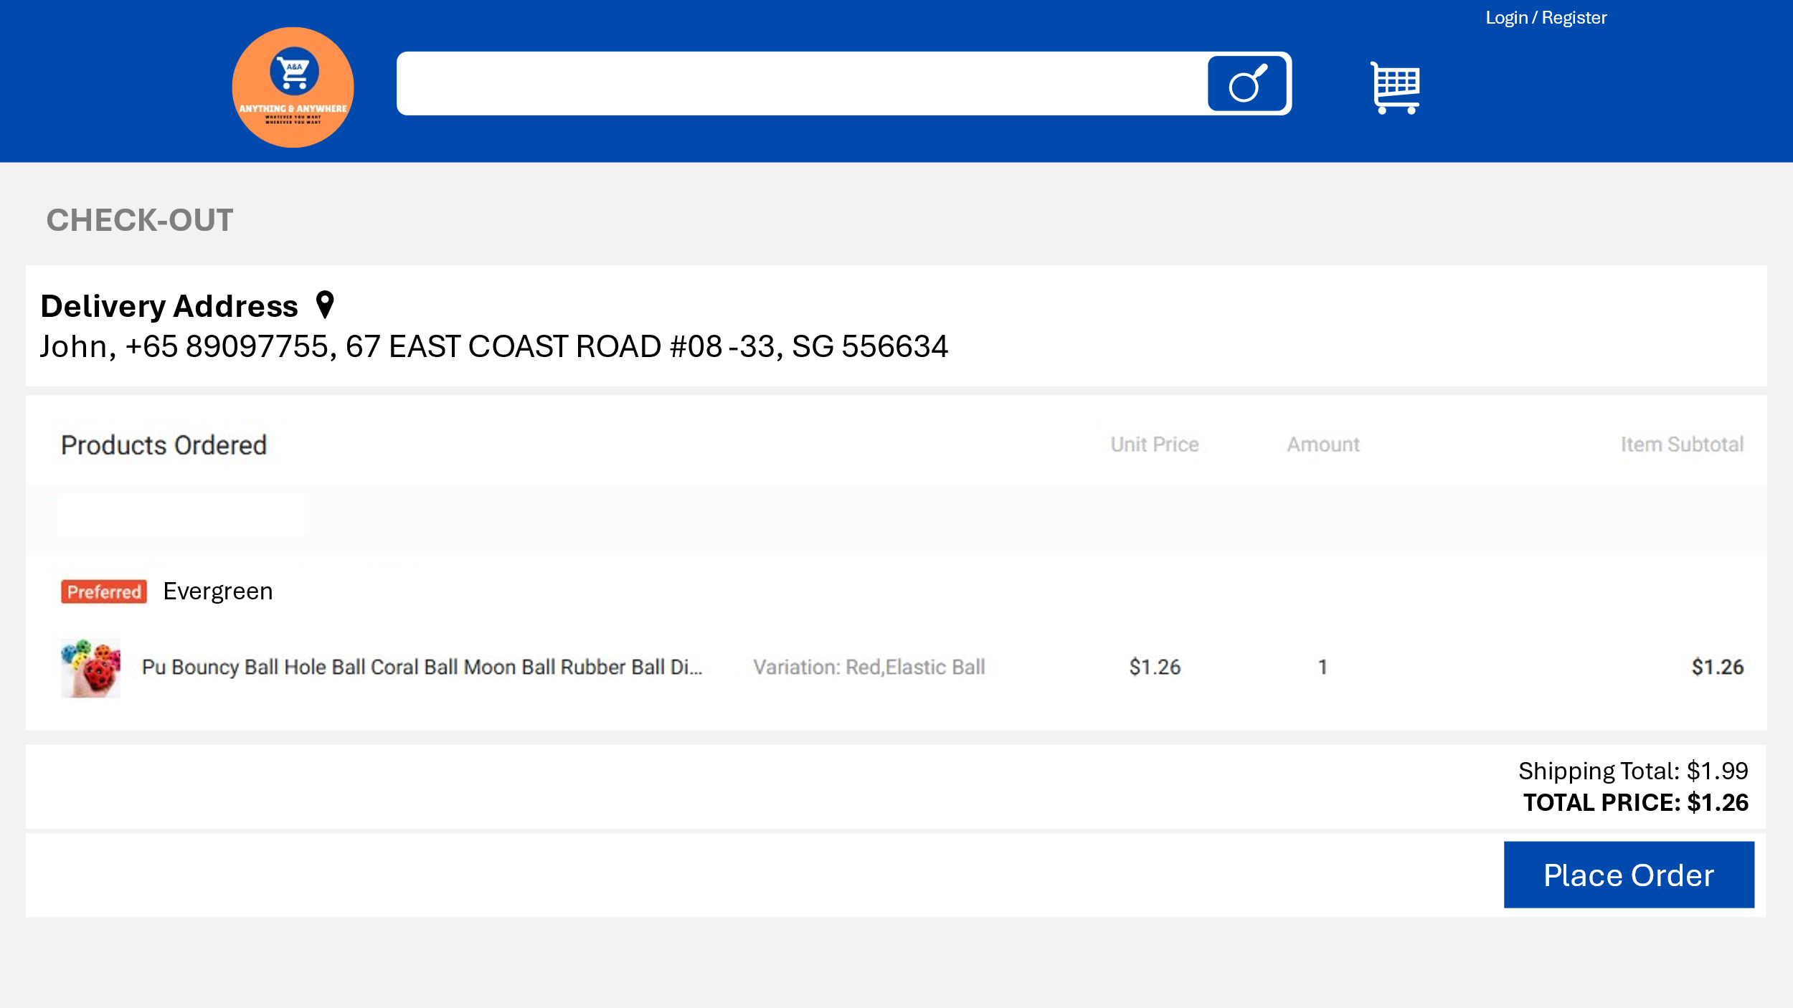

**Project Development**

**Text Editor:** Visual Studio Code

**VSCode Extension**: Bootstrap 4, HTML CSS Support, JavaScript (ES6) code snippets, Live Server, MongoDB for VS Code, GitHub Repositories

**MongoDB Gui:** MongoDB Compass (Port:27017)

**Node.js:** localhost:3001